**Java Programming**

**Name : B.Satlas Rohit**

**Regno : 2024503305**

**Addition Using GUI:**

**Code :**

**import javax.swing.*;  
import java.awt.*;  
import java.awt.event.ActionEvent;  
import java.awt.event.ActionListener;  
public class Main {  
 public static class Addition extends JFrame implements ActionListener {  
 JLabel label1, label2;  
 JTextField text1, text2;  
 JButton button1, button2;  
 Addition() {  
 label1 = new JLabel("Number 1");  
 label2 = new JLabel("Number 2");  
 text1 = new JTextField(10);  
 text2 = new JTextField(10);  
 button1 = new JButton("Add");  
 button2 = new JButton("Clear");  
 button1.addActionListener(this);  
 button2.addActionListener(this);  
 setLayout(new FlowLayout());  
 add(label1);  
 add(text1);  
 add(label2);  
 add(text2);  
 add(button1);  
 add(button2);  
 setSize(300, 200);  
 setVisible(true);  
 setDefaultCloseOperation(JFrame.*EXIT_ON_CLOSE*);  
 setTitle("Addition Program");  
 }  
 @Override  
 public void actionPerformed(ActionEvent e) {  
 if (e.getSource() == button1) { // Add button  
 try {  
 int num1 = Integer.*parseInt*(text1.getText());  
 int num2 = Integer.*parseInt*(text2.getText());  
 int sum = num1 + num2;  
 JOptionPane.*showMessageDialog*(this, "Sum = " + sum);  
 } catch (NumberFormatException ex) {  
 JOptionPane.*showMessageDialog*(this, "Please enter valid numbers!");  
 }  
 } else if (e.getSource() == button2) { // Clear button  
 text1.setText("");  
 text2.setText("");  
 }  
 }  
 }  
 public static void main(String[] args) {  
 new Addition();  
 }  
}**

**Output:**

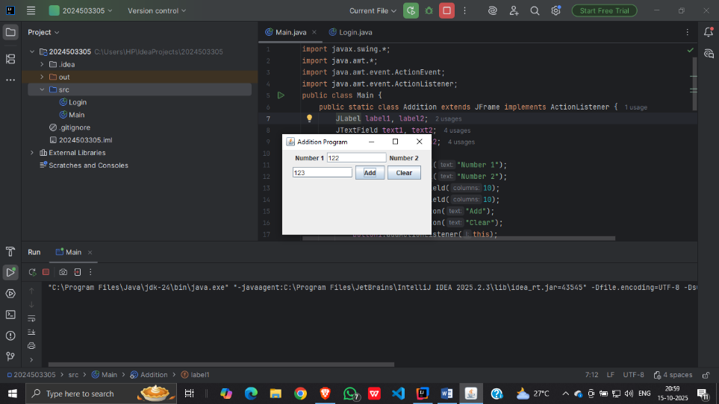

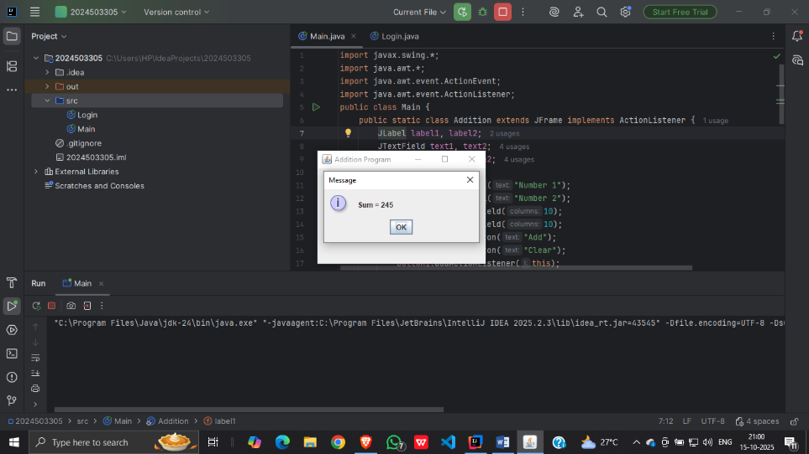

**Login Page Using GUI**

**Code:**

**import javax.swing.*;  
import java.awt.*;  
import java.awt.event.*;  
public class Login extends JFrame implements ActionListener {  
 JLabel userLabel, passLabel;  
 JTextField userText;  
 JPasswordField passText;  
 JButton loginButton, clearButton;  
 Login() {  
 userLabel = new JLabel("Username:");  
 passLabel = new JLabel("Password:");  
 userText = new JTextField(15);  
 passText = new JPasswordField(15);  
 loginButton = new JButton("Login");  
 clearButton = new JButton("Clear");  
 loginButton.addActionListener(this);  
 clearButton.addActionListener(this);  
 setLayout(new GridLayout(3, 2, 10, 10));  
 add(userLabel);  
 add(userText);  
 add(passLabel);  
 add(passText);  
 add(loginButton);  
 add(clearButton);  
 setTitle("Login Form");  
 setSize(300, 150);  
 setLocationRelativeTo(null); // Center the window  
 setDefaultCloseOperation(JFrame.*EXIT_ON_CLOSE*);  
 setVisible(true);  
 }  
 @Override  
 public void actionPerformed(ActionEvent e) {  
 if (e.getSource() == loginButton) {  
 String username = userText.getText();  
 String password = new String(passText.getPassword());  
 if (username.equals("admin") && password.equals("1234")) {  
 JOptionPane.*showMessageDialog*(this, "Login Successful!");  
 } else {  
 JOptionPane.*showMessageDialog*(this, "Invalid Username or Password!");  
 }  
 } else if (e.getSource() == clearButton) {  
 userText.setText("");  
 passText.setText("");  
 }  
 }  
 public static void main(String[] args) {  
 new Login();  
 }  
}**

**Output:**

